Demonstration: 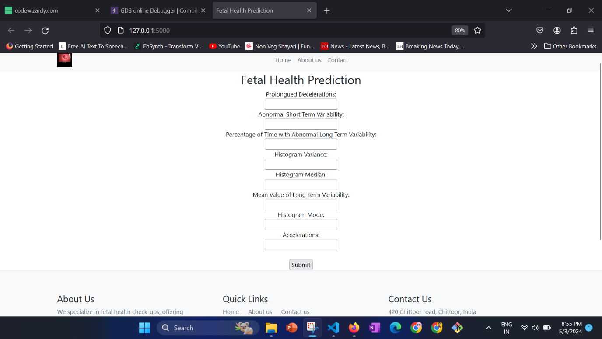

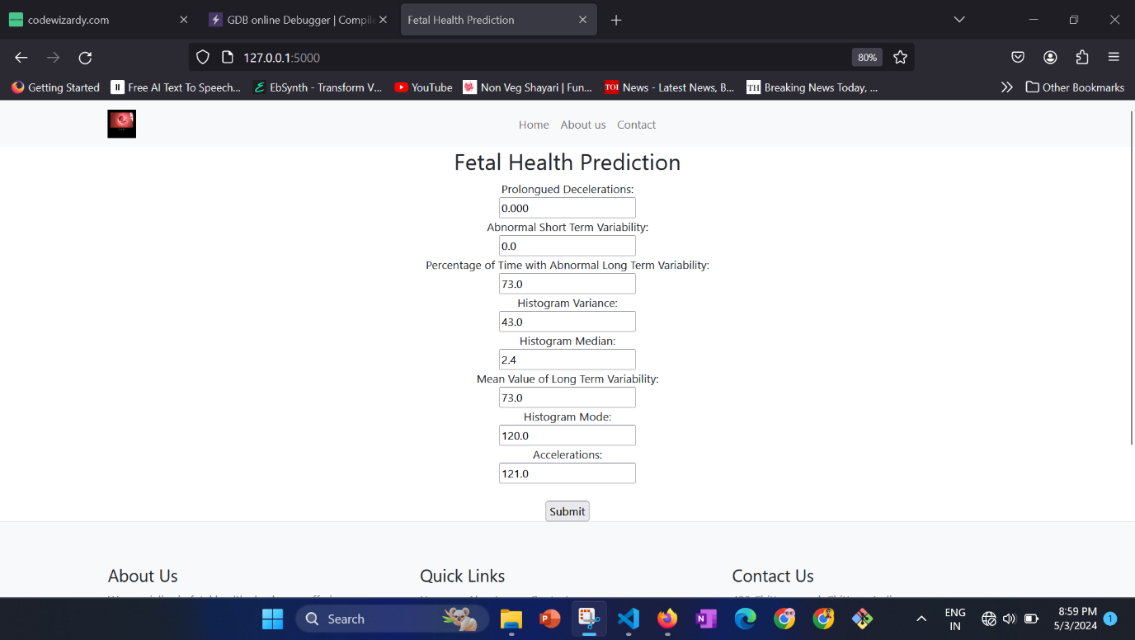

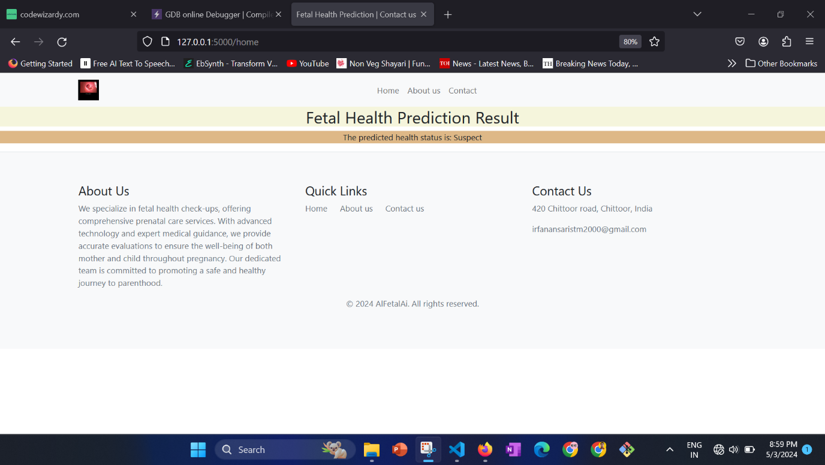

Youtube video link:

There is link for project demo-

<https://www.youtube.com/watch?v=OY4JXbjX0YY>